Lab Session 0x07

**Task 1: reversing .NET binaries (6p)**

*Perform the following tasks using the task1.exe binary:*

* *Investigate task1.exe however you see fit. Spend no more than 10-15 minutes trying to approach the binary as usual, with IDA Pro.*
* *Next, open the binary in the CFF Explorer and look for the “FileDescription” field. What value does the binary have and what does it mean?*

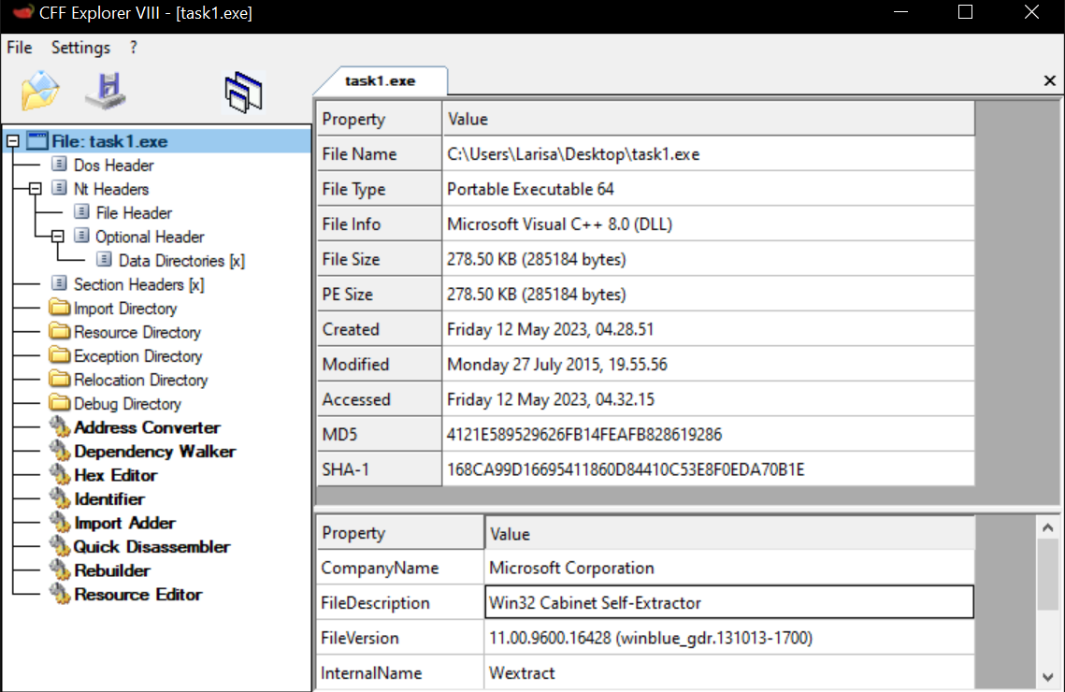

[Source](https://itstillworks.com/win32-extractor-12172265.html)

* *Open the binary in 7z or Winrar, extract the underlying executable and open it in IDA Pro. Explain why you think the extraction works. (2p)*

